CRM TEXT COMMANDER

USER’S MANUAL

Developed by Shinra Software Solutions, Inc. for Enzi Corporation

2017

By Everett Vergara

Shinra Software Solutions, Inc.

7/3/2017

*This Text Commander User’s Manual is a supplementary guideline in conjunction with the original SHINRA-ENZI Customer Relationship Management System Documentation. It follows the same text convention, content format and manual design to prevent confusion to the readers. Please take time to read SHINRA-ENZI Customer Relationship Management System Documentation before proceeding with this guide.*

*Thank you.*

**TABLE OF CONTENTS PAGE**

1. **TEXT COMMANDER** 4
   1. Overview 4
   2. Business Process 4
   3. Minimum Requirements 5
   4. Sending SMS 5
      1. Quick Send - Sending of SMS via the Pools Rowmanager
      2. Individual Send – Sending of SMS via Contract Master Data Entry
   5. Receiving SMS 8
      1. Instant Notification
   6. SMS Reconciliation 9
      1. Manual Recon – Unmatched SMS Inbox
   7. SMS Reports 10
      1. Sent SMS Report
      2. Received SMS Report
      3. Sent / Received by Network
      4. Unread SMS Report Summary
      5. Unread SMS Report Detailed
      6. Forbidden SMS Report
   8. Text Commander Master Files 12
      1. Network Carrier
      2. Mobile Prefixes
      3. Network Devices
      4. Forbidden Keywords
      5. Template Manager
   9. Text Commander Server 15
2. **ACKNOWLEDGEMENTS** 16
3. Overview 16
4. **TEXT COMMANDER**
   1. **OVERVIEW**

Prior to the implementation of TEXT COMMANDER, ENZI Corporation (ENZI) is utilizing OZEKI, a browser-based SMS messaging connected to SMS Server. Back then, ENZI users were in constant struggle on reporting as to how many card holders were informed of their outstanding balance per day, who were the card holders that were reminded of their obligations, and tedious reconciliation of received SMS just to name a few.

A customized solution, tailor-fitted to ENZI’s requirement is required to make SMS communication and reporting more efficient in a snap of a finger, in which, OZEKI will not be able to handle due to its lack of important features.

Text Commander is an SMS facility developed and customized for ENZI by Shinra Software Solutions, Inc., to automate the sending, receiving and reporting of text messages.

* 1. **BUSINESS PROCESS**

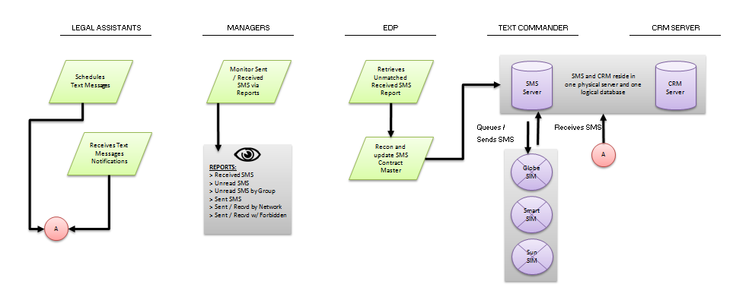

* 1. **REQUIREMENTS**

TEXT COMMANDER utilizes client-server architecture with broadband SMS devices connected directly to the server. Below are the minimum requirements of TEXT COMMANDER in order to run the system. The specifications of each can be adjusted to cater to smoother processing.

Minimum Client Requirements:

* Installed ENZI CRM version 1.78

Minimum Server Requirements:

* Intel Core 2 Duo
* 2 GB Memory
* 1 GB Hard Disk Space
* Windows 7

Broadband Requirements:

* Generic HWUAWEI MOBILE WIFI E5330 or Higher
* SIM CARD Slot
  1. **SENDING OF SMS**

By default, SMS sending is granted to the operations team, specifically Legal Assistants, Group Heads and Account Managers. Every message requested by user for sending is scheduled by TEXT COMMANDER’s queuing manager every (x) no. of seconds to the intended recipient.

* + - 1. Quick Send - Sending of SMS via the Pools Rowmanager

Users may perform batch sending of SMS via the Pools Rowmanager. This is applicable if you have to send the same template over a number of contract master records.

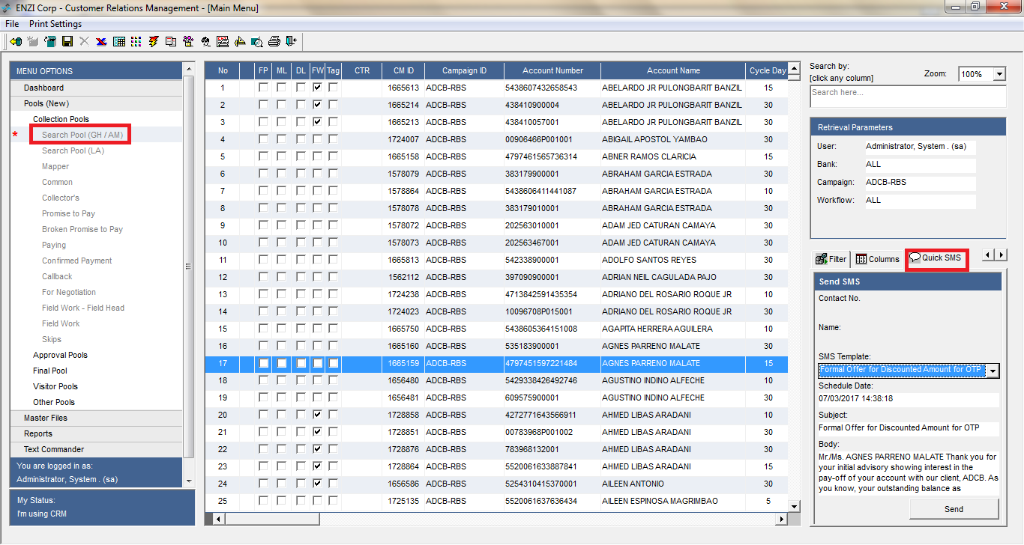

* + - Go to Main Menu then Pools Menu.
    - Choose any of the menu options
    - Select Quick SMS on lower panel of the Main Menu
      * Select a Contract Master Record (or highlight multiple records)
      * Under Quick SMS, Select the applicable template
      * Set SMS Schedule. Leave as is if you want Text Commander to Queue it ASAP.
      * Edit the Body text as necessary
      * Click the SEND button
      1. Individual Send – Sending of SMS via Contract Master Data Entry

Users may choose to send individual and personalized SMS to card holders via the contract master module.

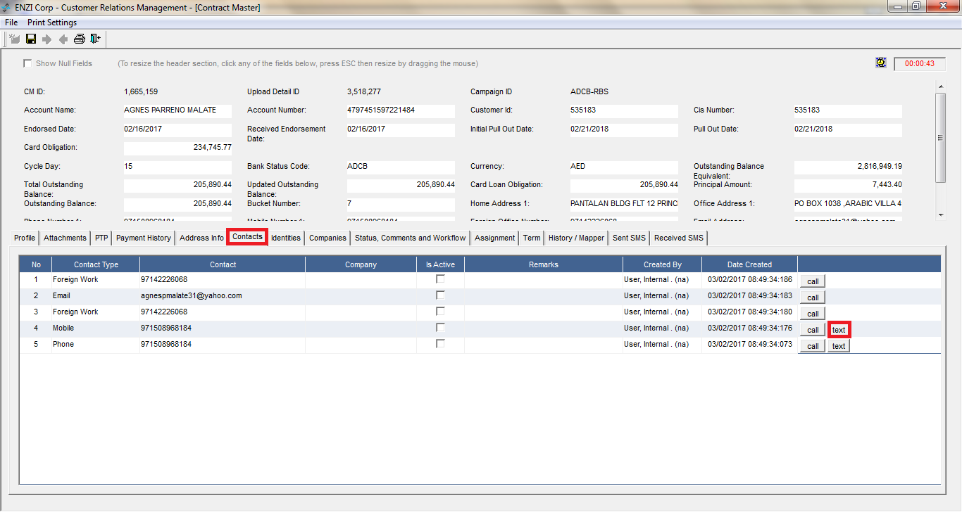

* + - 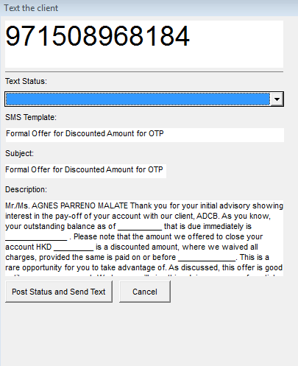Go to Main Menu then Pools Menu.
    - Choose any of the menu options
    - Open a contract master record
      * Select the Contacts TAB
      * You are allowed to SMS a card holder if information about his/her cellular number is provided.
      * Click the TEXT button and a screen similar to the right will appear.
      * Select the applicable template then fill-in all the necessary information.
      * Click the Post Status and Send Text
      * Your SMS will be queued automatically to TEXT COMMANDER for sending.
  1. **RECEIVING OF SMS**

ENZI is informed by automatically by the system that a new SMS message has been received for LA and/or GH accounts. This is made possible by integrating CRM with the TEXT COMMANDER Service.

1. Instant Notification – Receiving of SMS

Users will be able to view their respective SMS inbox notification via the Main Menu as shown below. This view is refreshed every 5 minutes by the CRM.

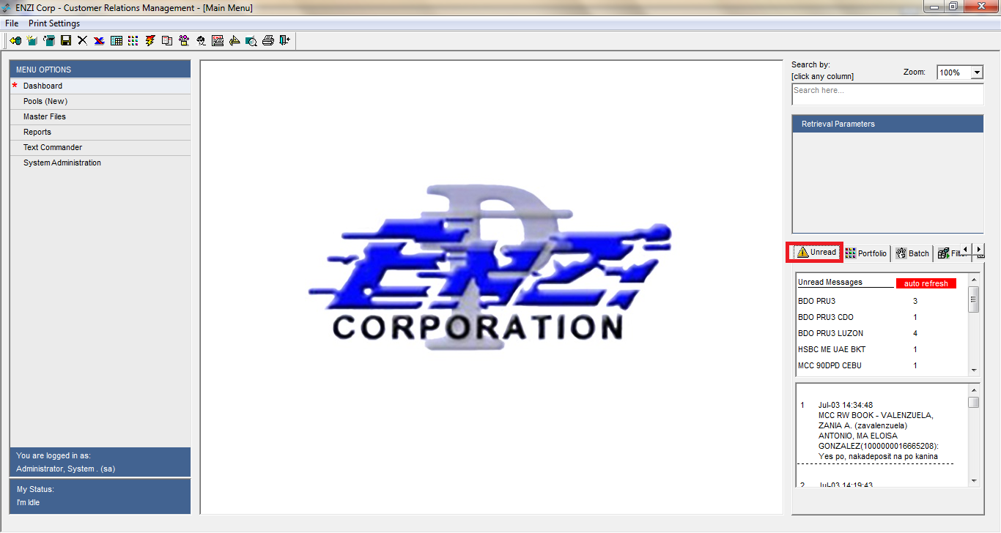

In case the user wants to view all SMS received for a particular card holder, simply follow the steps below:

* + - Go to Main Menu then Pools Menu.
    - Choose any of the menu options
    - Open a contract master record
    - Select SMS Received TAB as shown below

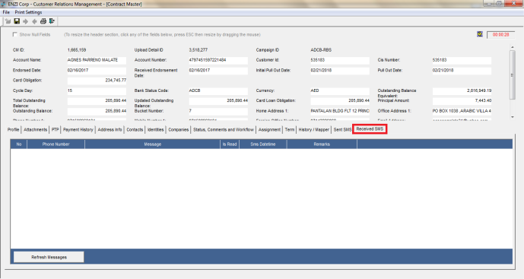

* 1. **UNRECONCILED SMS**

TEXT COMMANDER automatically matches all numbers of SMS inbox with the mobile of existing card holders. In the event that the system is not able to match the phone numbers, EDP needs to do manual reconciliation of text messages with respect to contract master records.

1. Manual Recon – Unmatched SMS Inbox

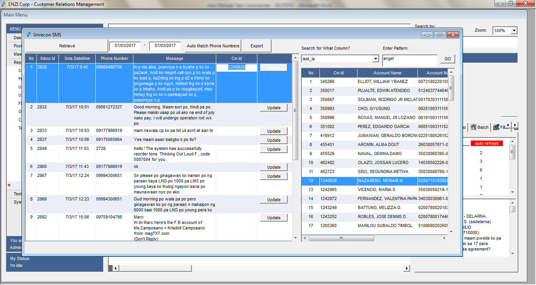

* + - Go to Main Menu then Reports
    - Select Text Commander Menu Option
    - Open Unrecon SMS
      * + Specify the date range of unmatched SMS Report
        + Select Retrieve
        + Click AUTO MATCH PHONE NUMBERS

This feature will auto match all phone numbers that have been newly created by LA or EDP with the UNRECON SMS.

* + - * + If EDP wants to proceed further with the manual recon and matching, search for any pattern in the contract master by indicating the column you want to search (window on the left), then value for the pattern. Click GO to retrieve all matching records. Copy the CM ID from the right window to the row of the left window if they match any criteria.
        + Click update in any of the rows to take effect the changes.

* 1. **SMS REPORTS**

TEXT COMMANDER comes with variation of reports to cater to the needs of ENZI. All reports can be found under Main Menu > Reports > Text Commander.

1. Sent SMS Report

Shows all sent SMS under the account of Legal Assistant or under the campaigns assigned to GH and Account Managers for a particular period and campaign.

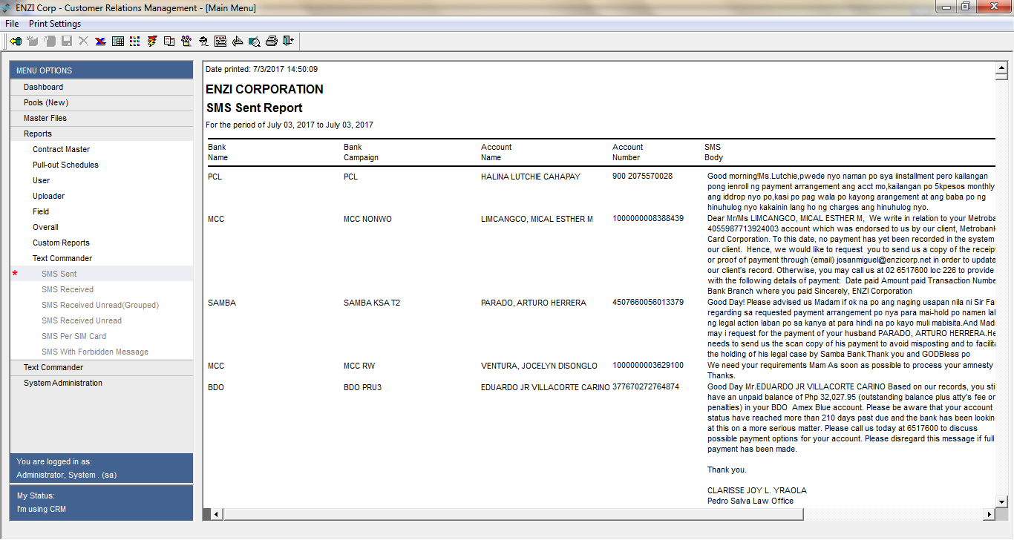

1. Received SMS Report

Shows all received SMS under the account of Legal Assistant or under the campaigns assigned to GH and Account Managers for a particular period and campaign.

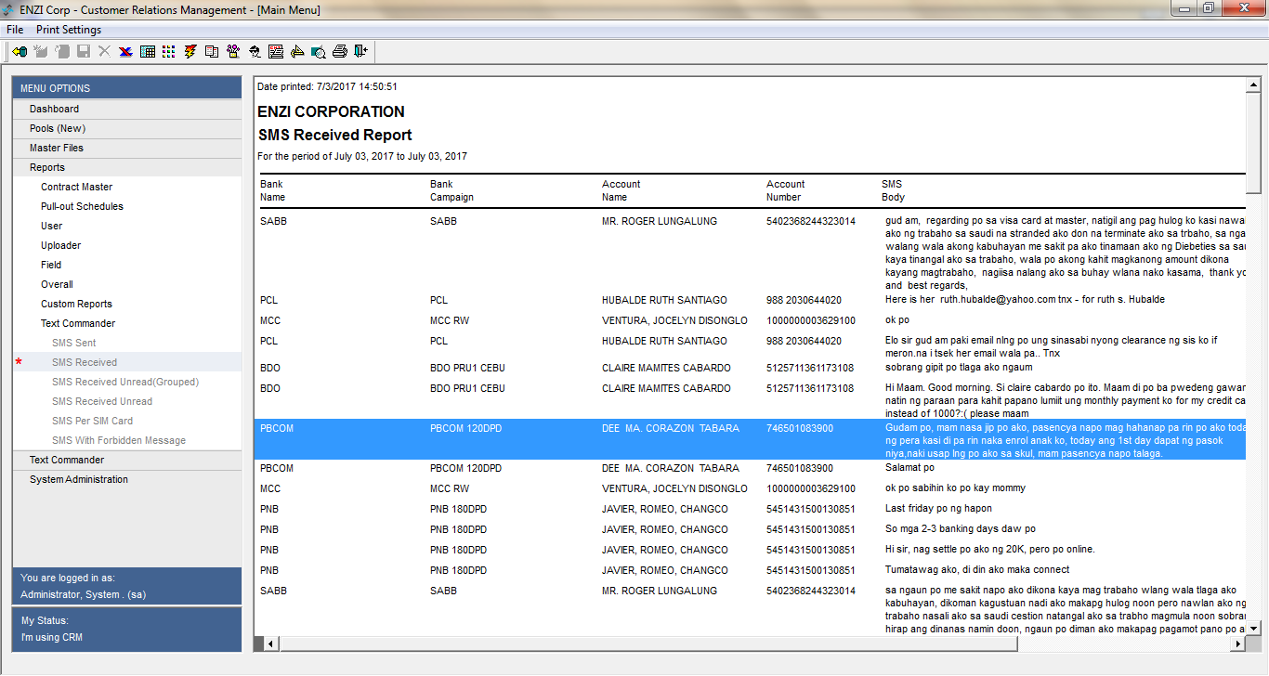

1. Sent / Received SMS by Network

Shows all sent / received SMS under the account of Legal Assistant or under the campaigns assigned to GH and Account Managers for a particular period and campaign. You can see the correlation of SMS activity vs. LA / Group performance through this report.

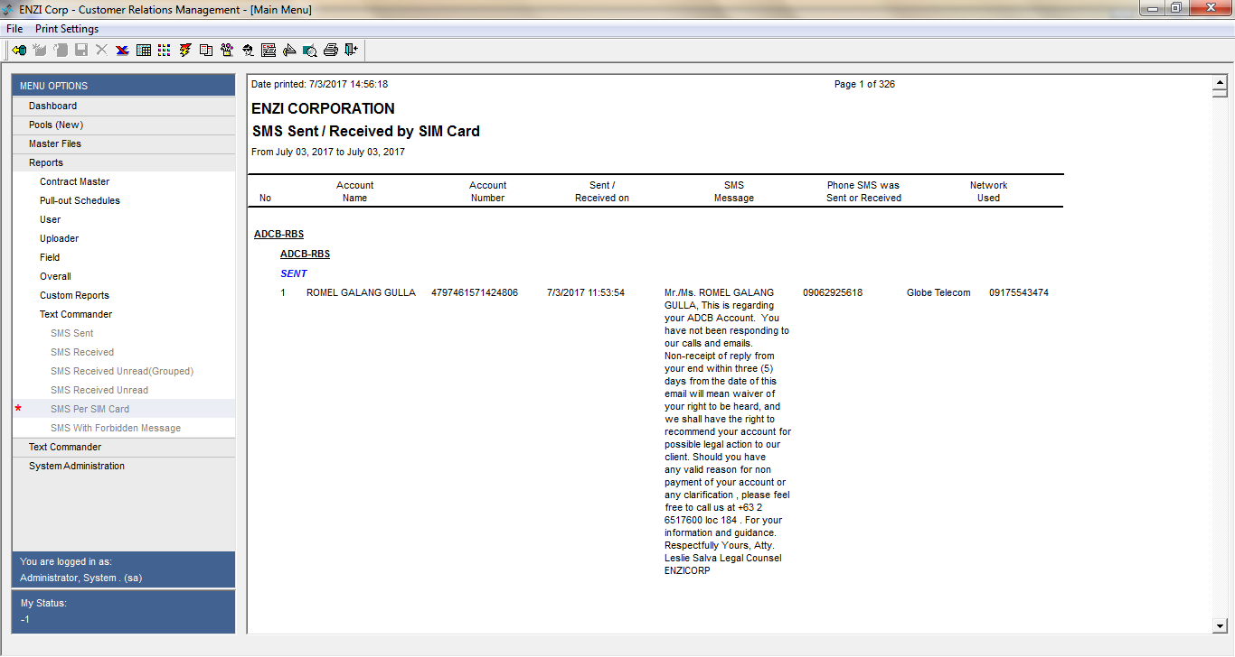

1. Unread SMS Report Summary

Shows unread SMS report Summary under the account of Legal Assistant or under the campaigns assigned to GH and Account Managers.

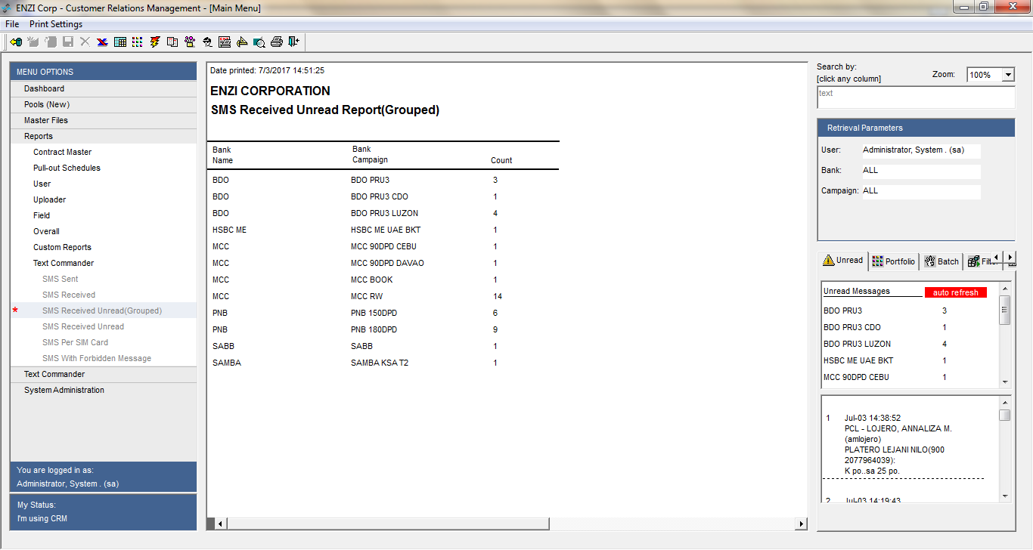

1. Unread SMS Report Detailed

Shows unread SMS report details under the account of Legal Assistant or under the campaigns assigned to GH and Account Managers.

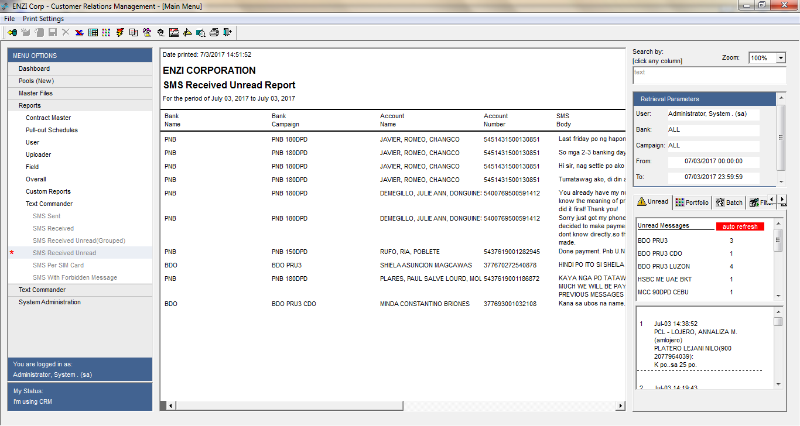

1. Forbidden SMS Report

Monitor the quality of your LA’s sent messages through this report. The report lists down all sent messages with forbidden keywords.

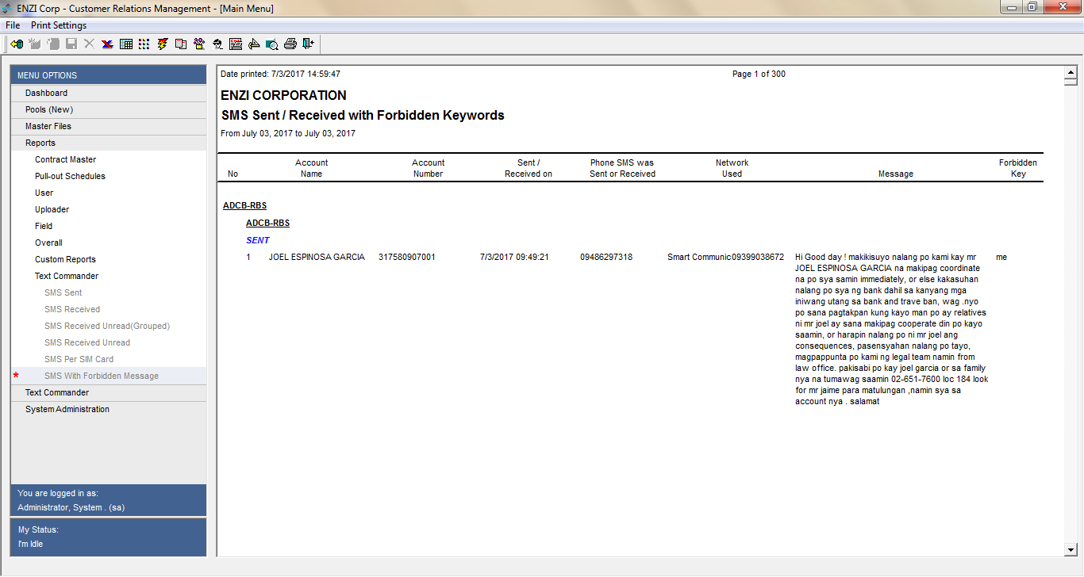

* 1. **TEXT COMMANDER MASTER FILES**

Before anything else, Text Commander must be configured properly through Master Files. It consists of several configuration files that the user needs to setup. These master files can be found under Main Menu > Text Commander > Text Commander.

* + 1. Network Carrier

This module shows list of network carrier.

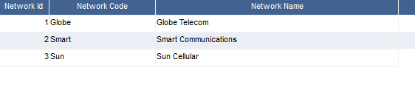

* + 1. Mobile Prefixes

This module lists all mobile prefixes with respect to the network carrier. This will be used to make sure the device is sending to the correct network carrier and to prevent unnecessary fees.

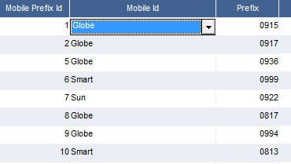

* + 1. Network Devices

Specifies and configures the broadband device and to what port it is connected.

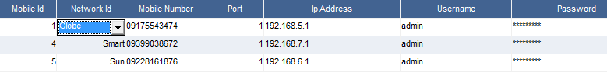

* + 1. Forbidden Keywords

This module maintains a list of forbidden keywords for reporting purposes.

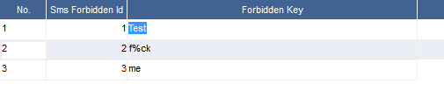

* + 1. Template Manager

Template manager is an editor that is used to automate sending of SMS.

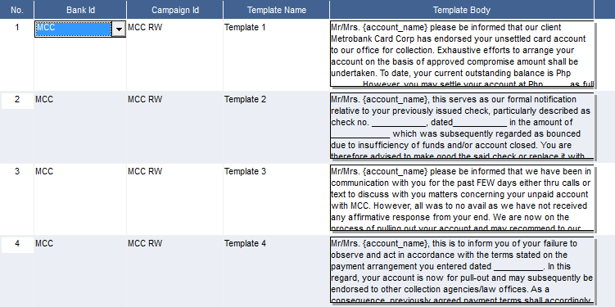

* 1. **TEXT COMMANDER SERVER**

Text Commander requires polling to fetch and schedule SMS from and to the Network devices.

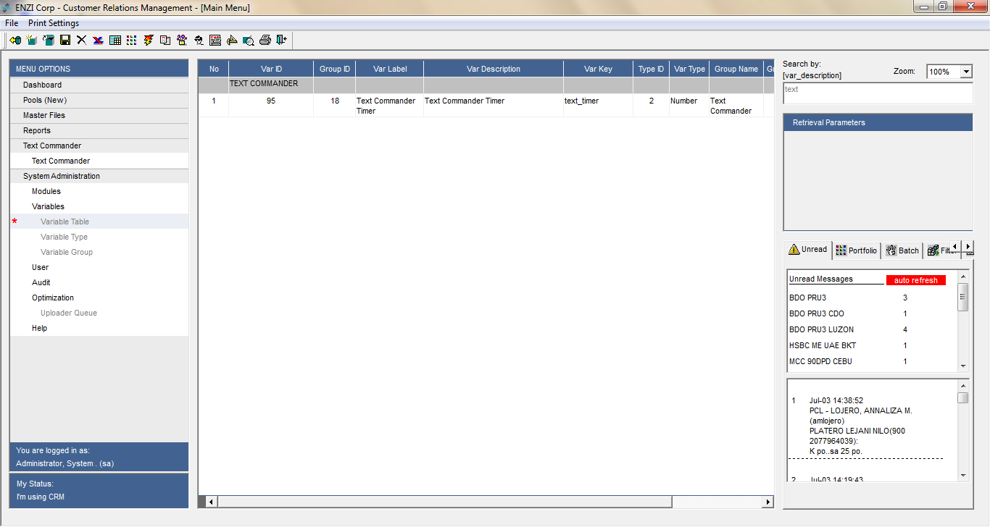

To set-up the frequency of sending and receiving text, follow the steps below:

* + - Go to Main Menu then System Administration
    - Select Variables Menu Option
    - Open Variables
      * + Click Var Label Column
        + From the searcher, type: text commander
        + Double click the record and change the value of seconds for the timer.

1. **ACKNOWLEDGEMENTS**

SHINRA would like to thank the entirety of ENZI CORPORATION for their guidance, patience and providing us the opportunity to participate and work on their CRM TEXT COMMANDER. We hope that the system serves its purpose to automate the processes needed to increase the LAs’ and Managers’ productivity.

On the other hand, we would like to give credits to following SHINRAnians who have made this project possible:

**PROJECT MANAGER**

Everett Vergara

**SYSTEMS ANALYST**

Everett Vergara

**PROGRAMMERS**

Reymon Bajao

Rad Atienza

Reiner Singson

Neil Cuenza

**TRAINING AND DOCUMENTATION**

Reymon Bajao

**SALES**

Zenny Dimakiling

**COLLECTION FOLLOW-UPS**

Zenny Dimakiling

Thank you

… End of Document …